**Steps to Create a GitHub Account:**

1. **Go to GitHub – Visit** [**https://github.com/**](https://github.com/)**.**
2. **Sign Up – Click Sign up in the top-right corner.**

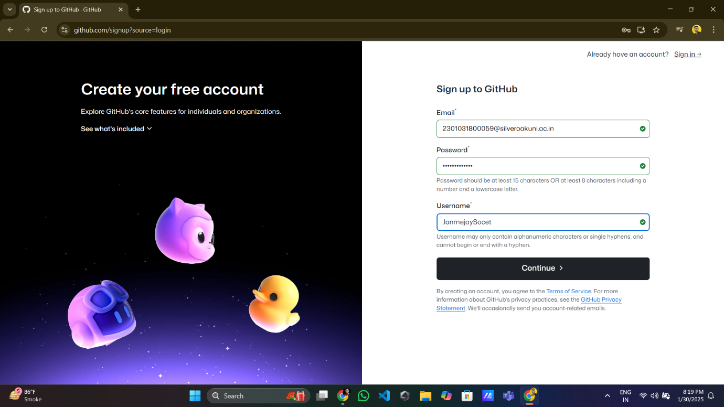

1. **Verify Email** – GitHub will send a verification code to your email. Enter it.
2. **Finish Setup** – Click **Create Account** and explore GitHub.

**Steps to Create a Repository on GitHub:**

1. **Login** – login to your account using username and password

1. **Create a New Repo** – Click the green **"New"** button.

1. **Enter Details – Provide:**

**Repository name**

**Description (optional)**

**Choose Public or Private**

1. **Create Repository – Click the "Create repository" button.**

